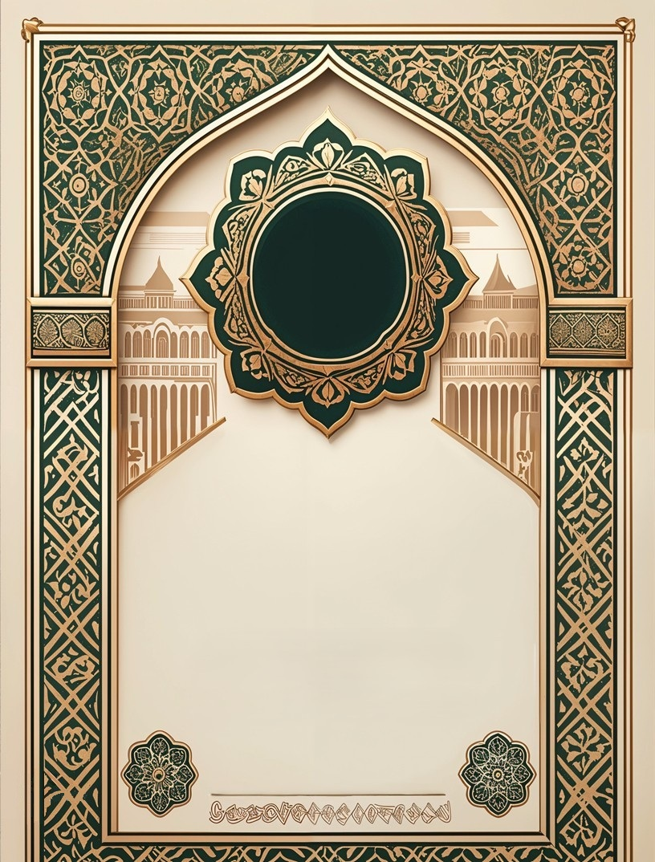

|  |
| --- |
| قَدْ أَفْلَحَ |

مدرسة الإتقان الإسلامية

ItQaan Institute Inc Presents:

|  |
| --- |
| **The student: ____________________________** |
| **On the date: ____________________________** |
| Completed Juz ___ of 30 |
| **Honored By The Principal Teacher**  x **من فضيلة الشيخ الأستاذ:** |

x